**1.Osteoporosis**

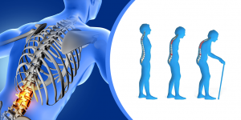

**Symptoms:**

* Shortness of Breath
* Lower Back pain
* change In body posture etc…

**Exercise:**

 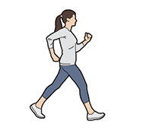 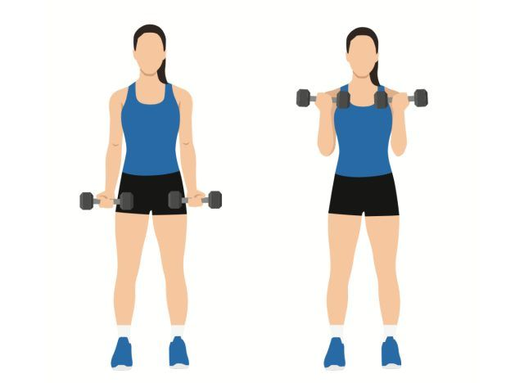

jogging

walking

Weight lifting

**Stretching:**

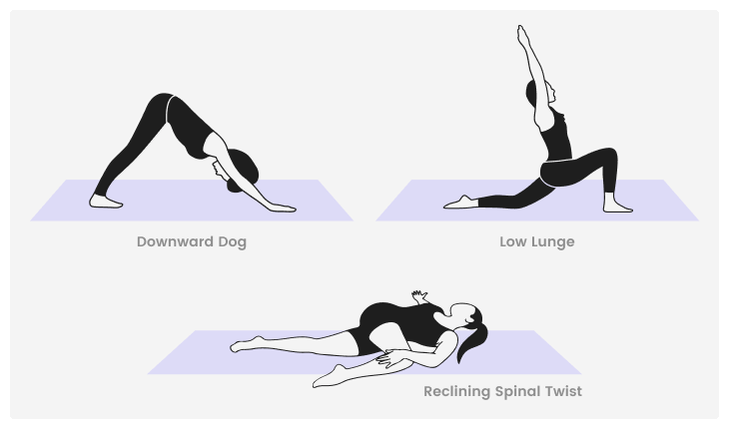

Try to stretch for at least five to 10 minutes after every workout. Hold each stretch for 10 to 30 seconds.



helps increase bone density and slows down bone los



**Foods to Eat:**

1. **Calcium-Rich Foods:**
   * **Dairy Products:** Milk, yogurt, cheese.
   * **Leafy Greens:** Kale, collard greens, bok choy.
   * **Fortified Foods:** Orange juice, plant-based milks (like almond or soy milk), breakfast cereals.
   * **Fish with Edible Bones:** Sardines, salmon.
2. **Vitamin D-Rich Foods:**
   * **Fatty Fish:** Salmon, mackerel, sardines.
   * **Fortified Foods:** Fortified milk, cereals, and orange juice.
   * **Egg Yolks:** Small amounts can be a source of vitamin D.
3. **Other Bone-Healthy Nutrients:**
   * **Magnesium-Rich Foods:** Nuts, seeds, whole grains, avocados.
   * **Vitamin K-Rich Foods:** Leafy greens like spinach, kale, and broccoli.
   * **Protein-Rich Foods:** Lean meats, poultry, fish, legumes (for overall health and bone repair).

**Foods to Avoid:**

1 .**High-Sodium Foods:**

* **Processed Foods:** Canned soups, salty snacks, and processed meats. Excessive sodium can lead to calcium loss through urine.

2. **Caffeine:**

* **Caffeinated Beverages:** Coffee, tea, and some sodas. Excessive caffeine can interfere with calcium absorption.

3 .**Alcohol:**

* **Excessive Alcohol Consumption:** Can interfere with calcium absorption and bone formation. Aim to limit intake to moderate levels.

4.**High-Phosphorus Foods:**

* **Colas and Certain Processed Foods:** High phosphorus levels can impact calcium balance in the body.

**Additional Tips:**

* **Weight-Bearing Exercise:** Incorporate activities like walking, dancing, and resistance training to help strengthen bones.
* **Regular Check-Ups:** Have regular bone density tests as recommended by your healthcare provider.
* **Hydration:** Drink plenty of water to support overall health and prevent dehydration, which can negatively affect bone health.

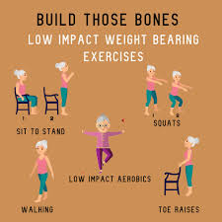 

**2.Insomenia**

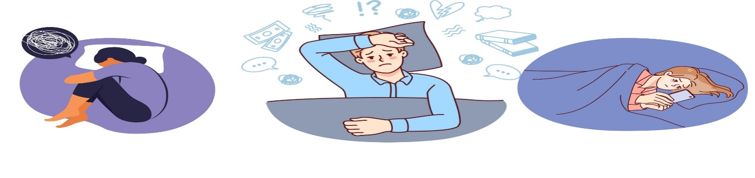

**Symptoms:**

* Having a hard time falling asleep at night.
* Waking up during the night.
* Feeling tired or sleepy during the day.
* Feeling cranky, depressed or anxious.

**Exercise:**



* Jump rope
* Running
* Rowing
* Swimming
* Cycling
* Jogging etc..

**YOGA Practice For Insomenia:**

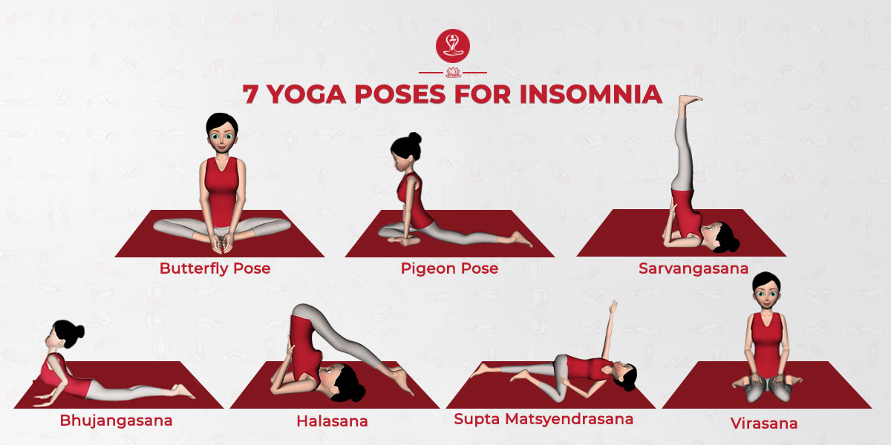

* Butterfly pose
* pigeon pose
* Sasrvangasana
* bhujangasana
* Halasana
* Supta matsyendrasana
* virasana

**Benefits:**

cardio workouts, also called aerobic exercise, such as swimming, biking, jogging, or walking, may help you sleep. You may also see some improvement in sleep apnea symptoms.

**Foods to Eat:**

1. **Tryptophan-Rich Foods:**
   * **Turkey:** Known for its sleep-promoting tryptophan content.
   * **Chicken:** Another good source of tryptophan.
   * **Nuts and Seeds:** Pumpkin seeds, chia seeds, and almonds.
   * **Dairy Products:** Milk, yogurt, and cheese.
2. **Melatonin-Rich Foods:**
   * **Fruits:** Cherries (especially tart cherries), grapes.
   * **Vegetables:** Tomatoes, corn.
   * **Nuts:** Almonds, walnuts.
3. **Magnesium-Rich Foods:**
   * **Leafy Greens:** Spinach, Swiss chard.
   * **Nuts and Seeds:** Almonds, sunflower seeds.
   * **Legumes:** Black beans, lentils.
4. **Calcium-Rich Foods:**
   * **Dairy Products:** Milk, cheese, yogurt.
   * **Fortified Non-Dairy Milks:** Almond, soy, or oat milk.
5. **Herbal Teas:**
   * **Chamomile Tea:** Known for its calming effects.
   * **Peppermint Tea:** Can be soothing and aid digestion.

**Foods to Avoid:**

1. **Caffeine:**
   * **Coffee and Tea:** Especially in the afternoon and evening.
   * **Energy Drinks:** High caffeine content can disrupt sleep.
2. **High-Sugar Foods:**
   * **Sugary Snacks and Desserts:** Can cause fluctuations in blood sugar levels, impacting sleep.
3. **Heavy or Spicy Foods:**
   * **Rich or Fatty Foods:** Such as pizza, burgers, and fried foods, can cause discomfort and indigestion.
   * **Spicy Foods:** Can cause heartburn and disrupt sleep.
4. **Alcohol:**
   * **Excessive Consumption:** Alcohol can initially induce sleep but may lead to fragmented sleep patterns.
5. **Large Meals Late at Night:**
   * **Heavy Dinners:** Can cause discomfort and indigestion, affecting sleep quality.

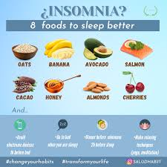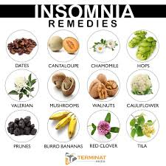

**3.Asthama**

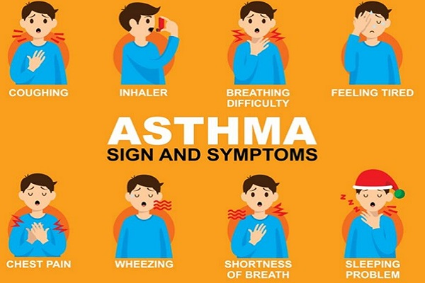

**Symptoms:**

* Shortness of breath.
* Chest tightness or pain.
* Wheezing when exhaling, which is a common sign of asthma in children.
* Trouble sleeping caused by shortness of breath, coughing or wheezing.
* Coughing or wheezing attacks that are worsened by a respiratory virus, such as a cold or the flu.

**Exercise:**

**Yoga practises for asthama**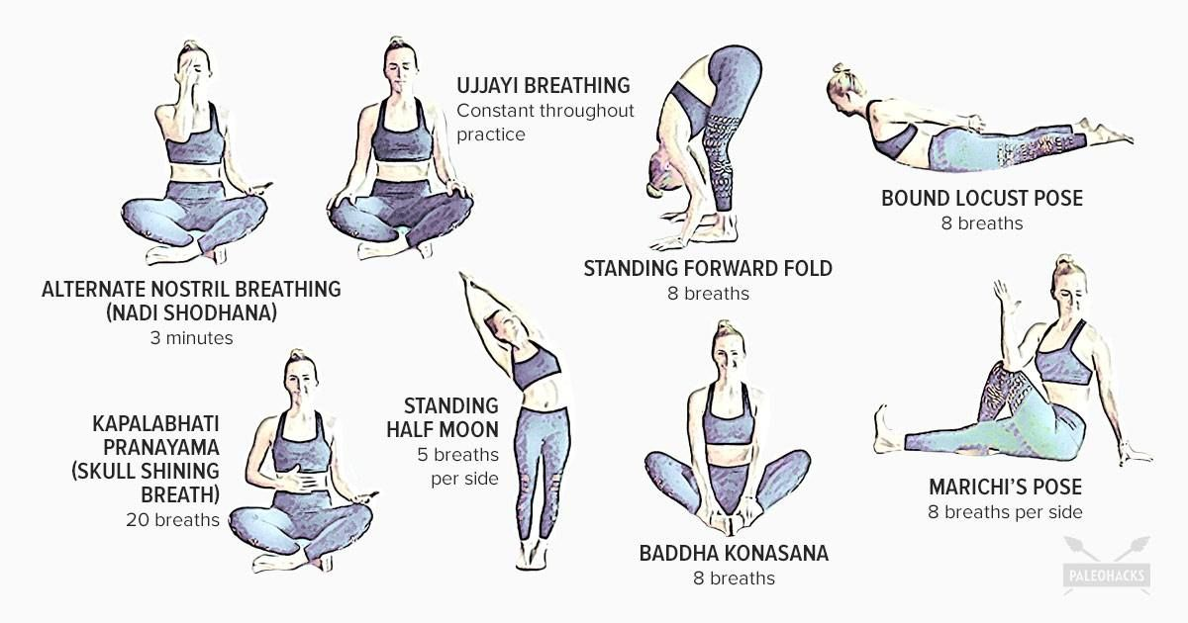

* Ujjayi breathing
* Nadisodhana
* Stand forward fold
* Bound locust phose
* Badda konasana
* Marchis phose
* Kapalabhati
* Standing half moon

**Benefits:**

* Improved lung function and capacity.
* Enhanced relaxation and stress reduction.
* Better control over asthma triggers.
* Reduced reliance on medication.
* Increased overall well-being and quality of life.

**Foods to Eat:**

1. **Anti-Inflammatory Foods:**
   * **Fruits:** Berries, apples, and oranges, which are rich in antioxidants.
   * **Vegetables:** Spinach, kale, and broccoli.
   * **Nuts and Seeds:** Walnuts, flaxseeds, and chia seeds, which are rich in omega-3 fatty acids.
2. **Omega-3 Fatty Acids:**
   * **Fatty Fish:** Salmon, mackerel, and sardines.
   * **Flaxseed Oil:** A good plant-based source of omega-3s.
   * **Chia Seeds:** Can be added to smoothies or yogurt.
3. **Vitamin D-Rich Foods:**
   * **Fatty Fish:** Salmon, mackerel, and sardines.
   * **Fortified Foods:** Fortified milk or plant-based milks, fortified cereals.
4. **Magnesium-Rich Foods:**
   * **Leafy Greens:** Spinach, Swiss chard.
   * **Nuts and Seeds:** Almonds, sunflower seeds.
   * **Whole Grains:** Brown rice, quinoa.
5. **Foods High in Vitamin C:**
   * **Fruits:** Oranges, kiwi, strawberries.
   * **Vegetables:** Bell peppers, Brussels sprouts.

**Foods to Avoid:**

1. **Trigger Foods:**
   * **Common Allergens:** Nuts, shellfish, and dairy (if you have specific allergies that trigger asthma).
   * **Foods with Additives:** Certain preservatives and food colorings, like sulfites, which can trigger asthma symptoms.
2. **High-Sugar Foods:**
   * **Sugary Snacks and Beverages:** Can contribute to inflammation and exacerbate asthma symptoms.
3. **Processed Foods:**
   * **Fast Food and Processed Snacks:** Often high in unhealthy fats and additives, which can contribute to inflammation.
4. **Fried Foods:**
   * **Fried Snacks and Meals:** High in unhealthy fats which may exacerbate inflammation.

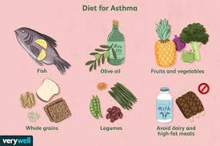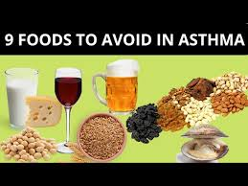

**4.Ankle sprains**

A sprain is an injury to the ligaments and capsule of a joint in the body. A strain is an injury to muscles or tendons.



**Symptoms:**

* pain or tenderness
* swelling
* bruising
* muscle spasms or cramping
* muscle weakness
* limited movement in the area

**Exercise:**

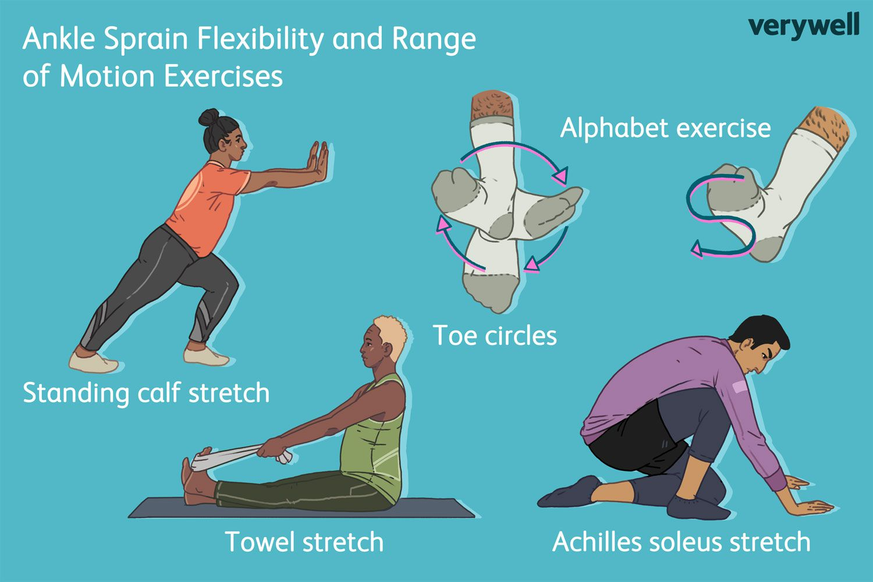

* Standing calf stretch
* Toe circles
* Alphabet exercise
* Towel stretch
* Achilles soleus stretch

**Benefits:**

After an ankle sprain, it's important to start doing exercises again as soon as you can. You might be stiff and sore, but the sooner you get it moving, the quicker you'll recover and better you'll avoid further injury.

**Foods to Eat:**

1. **Anti-Inflammatory Foods:**
   * **Fruits:** Berries (such as strawberries, blueberries, and raspberries) and cherries are high in antioxidants and can help reduce inflammation.
   * **Vegetables:** Leafy greens (like spinach and kale), broccoli, and bell peppers have anti-inflammatory properties.
   * **Nuts and Seeds:** Walnuts, almonds, and flaxseeds provide omega-3 fatty acids, which can help reduce inflammation.
2. **Protein-Rich Foods:**
   * **Lean Meats:** Chicken, turkey, and lean cuts of beef are important for muscle repair.
   * **Fish:** Salmon and tuna are good sources of protein and omega-3 fatty acids.
   * **Legumes:** Beans, lentils, and chickpeas offer plant-based protein and are also high in fiber.
3. **Vitamin C-Rich Foods:**
   * **Fruits:** Oranges, kiwi, and strawberries.
   * **Vegetables:** Bell peppers, tomatoes, and Brussels sprouts.
   * **Vitamin C** helps in collagen synthesis, which is crucial for tissue repair.
4. **Vitamin D-Rich Foods:**
   * **Fatty Fish:** Salmon and mackerel.
   * **Fortified Foods:** Fortified milk, orange juice, and cereals.
   * **Eggs:** The yolks are a good source of vitamin D.
5. **Magnesium-Rich Foods:**
   * **Nuts and Seeds:** Almonds, pumpkin seeds, and sunflower seeds.
   * **Leafy Greens:** Spinach and Swiss chard.
   * **Whole Grains:** Brown rice, quinoa, and oats.
6. **Hydration:**
   * **Water:** Staying hydrated is important for overall health and can help the body heal more efficiently.

**Foods to Avoid:**

1. **High-Sugar Foods:**
   * **Sugary Snacks and Beverages:** Can contribute to inflammation and interfere with healing.
2. **Processed Foods:**
   * **Fast Food and Packaged Snacks:** Often high in unhealthy fats and additives that can increase inflammation.
3. **Excessive Salt:**
   * **Salty Snacks and Processed Foods:** High sodium levels can contribute to water retention and swelling.
4. **Fried Foods:**
   * **Deep-Fried Snacks and Meals:** High in unhealthy fats which can exacerbate inflammation.

**Additional Tips:**

* **Follow R.I.C.E. Protocol:** Rest, Ice, Compression, and Elevation are key steps in managing an acute ankle sprain. Applying ice and keeping the ankle elevated can help reduce swelling.
* **Gradual Reintroduction to Activity:** As you heal, gradually reintroduce movement and physical therapy exercises to restore strength and flexibility to the ankle.
* **Supportive Footwear:** Use supportive shoes to prevent further strain on the ankle.
* **Proper Rehabilitation:** Engage in physical therapy if recommended to ensure full recovery and prevent future injuries.

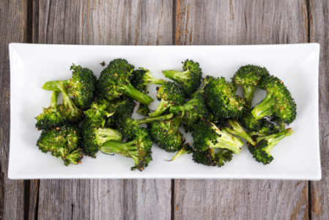

**5.Period cramps**

Cramps and pelvic pain with menstruation, with common causes such as heavy flow, passing clots, uterine fibroids or endometriosis.

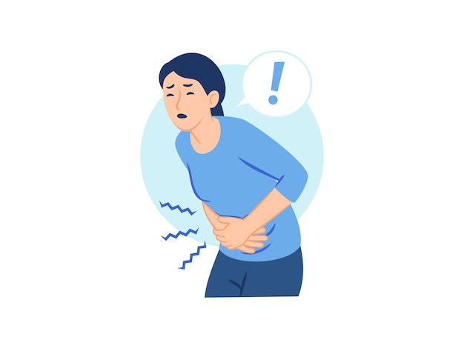

**Symptoms**

* Throbbing or cramping pain in your lower abdomen that can be intense.
* Pain that starts 1 to 3 days before your period, peaks 24 hours after the onset of your period and subsides in 2 to 3 days.
* Dull, continuous ache.
* Pain that radiates to your lower back and thighs.

**Exercise:**

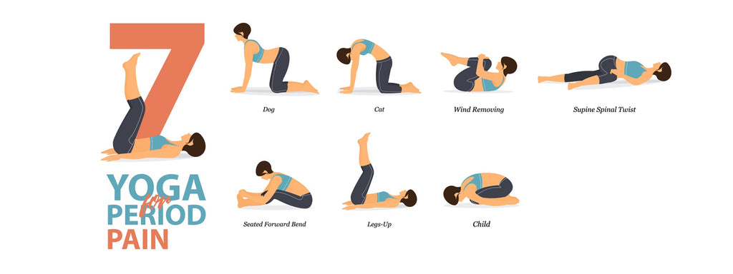

* Wind removing
* Spine spinal twist
* Dog standing position
* Child pose(balasana)
* Seated forward bend
* Legs up
* Cat position

**Benefits:**

During lighter menstrual days, try moderate-intensity aerobic exercises like walking or light jogging. This type of physical activity can reduce bloating (extra water weight) and the pain of cramping. Aerobic exercise helps your blood circulation and the release of “feel-good hormones” called endorphins (en DORF ins).

**Foods to Include:**

1. **Leafy Greens:** Spinach, kale, and other leafy greens are high in magnesium and can help relax muscles and reduce cramps.
2. **Fatty Fish:** Salmon, mackerel, and sardines are rich in omega-3 fatty acids, which have anti-inflammatory properties that can help reduce pain.
3. **Nuts and Seeds:** Almonds, flaxseeds, and chia seeds are good sources of magnesium and omega-3s.
4. **Whole Grains:** Brown rice, quinoa, and whole-wheat products can help regulate blood sugar levels and provide sustained energy.
5. **Fruits:** Berries, bananas, and oranges are rich in antioxidants, vitamins, and minerals that can help ease menstrual symptoms.
6. **Herbal Teas:** Ginger or chamomile tea can help reduce inflammation and ease muscle cramps.
7. **Yogurt:** Rich in calcium, yogurt can help reduce muscle tension and cramps.

**Foods to Avoid:**

1. **Salty Foods:** High salt intake can cause water retention and bloating, which can exacerbate menstrual cramps.
2. **Sugary Foods:** Excessive sugar can lead to blood sugar spikes and crashes, which may worsen cramping and mood swings.
3. **Caffeinated Drinks:** Coffee, tea, and energy drinks can increase tension and dehydration, potentially making cramps worse.
4. **Fatty Foods:** Fried foods and those high in saturated fats can increase inflammation and worsen pain.
5. **Processed Foods:** These often contain high levels of sodium and unhealthy fats, which can contribute to bloating and discomfort.
6. **Alcohol:** It can dehydrate you and may exacerbate cramping and mood swings.

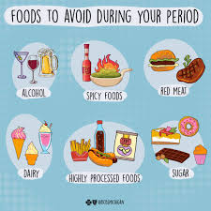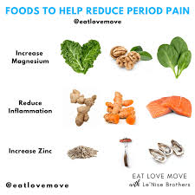

**6.Stress and anxity**

A mental health disorder characterised by feelings of worry, anxiety or fear that are strong enough to interfere with one's daily activities.



**Symptoms and patterns:**

* trouble concentrating or making decisions.
* feeling irritable, tense or restless.
* experiencing nausea or abdominal distress.
* having heart palpitations.
* sweating, trembling or shaking.
* trouble sleeping.
* having a sense of impending danger, panic or doom.

**Exercise:**

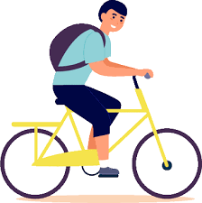

Meditation

Jogging

Cycling

Nature Walk

**Benefits:**

* Improving Mood and Self-Esteem
* Improving Cognitive Function
* Reducing Symptoms of Depression and Anxiety
* Reducing Stress Levels
* Increases confidence
* Keeps you more active
* Feels fresh and relaxed

Managing stress and anxiety through diet can be quite effective, as certain foods can help stabilize mood and improve overall well-being. Here’s a guide on what to include and avoid:

**Foods to Include:**

1. **Leafy Greens:** Spinach, kale, and other greens are rich in magnesium, which helps regulate mood and reduce anxiety.
2. **Fatty Fish:** Salmon, mackerel, and sardines are high in omega-3 fatty acids, which have been shown to lower levels of anxiety.
3. **Nuts and Seeds:** Almonds, walnuts, and flaxseeds are good sources of omega-3s and magnesium. They also provide healthy fats that support brain health.
4. **Whole Grains:** Brown rice, oats, and quinoa can help stabilize blood sugar levels, which in turn can stabilize mood and energy levels.
5. **Berries:** Blueberries, strawberries, and raspberries are high in antioxidants, which help combat oxidative stress and support brain health.
6. **Yogurt and Fermented Foods:** Probiotics found in yogurt, kefir, sauerkraut, and kimchi can support gut health, which is linked to mood regulation.
7. **Avocado:** High in healthy fats and B vitamins, avocados can support brain function and reduce stress.

**Foods to Avoid:**

1. **Sugary Foods:** Excessive sugar can lead to blood sugar spikes and crashes, which may worsen anxiety and mood swings.
2. **Caffeine:** Coffee, tea, and energy drinks can increase anxiety levels and interfere with sleep, leading to more stress.
3. **Alcohol:** While it might initially seem to reduce stress, alcohol can lead to dehydration and disrupt sleep patterns, ultimately worsening anxiety.
4. **Refined Carbs:** White bread, pastries, and other processed foods can cause rapid blood sugar fluctuations, which can impact mood and energy.
5. **Trans Fats:** Found in many processed and fried foods, these can increase inflammation and negatively affect brain health.
6. **High-Sodium Foods:** Excessive salt can lead to water retention and increased blood pressure, which may exacerbate feelings of anxiety.

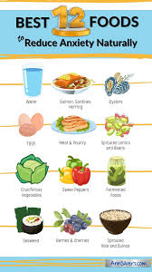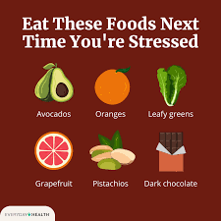

**7.** **Diabetes**

Diabetes is a chronic disease that occurs either when the pancreas does not produce enough insulin or when the body cannot effectively use the insulin it produces. Insulin is a hormone that regulates blood glucose.

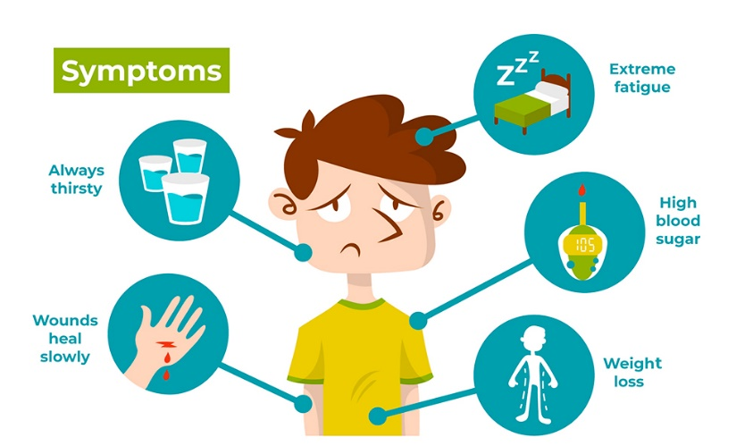

**Symptoms:**

* Urinate (pee) a lot, often at night.
* Are very thirsty.
* Lose weight without trying.
* Are very hungry.
* Have blurry vision.
* Have numb or tingling hands or feet.
* Feel very tired.
* Have very dry skin.

**Exercise:**

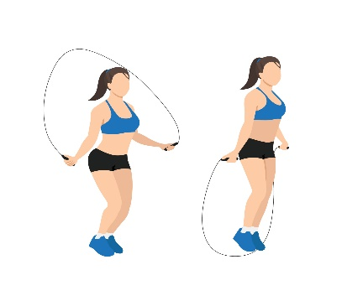

**Walking**

swimming

Surya namaskar

Jump rope

**Benefits:**

Physical exercise and yoga helps the body use insulin better by increasing insulin sensitivity. help you look after your blood pressure, because high blood pressure means you're more at risk of diabetes complications. help to improve cholesterol (blood fats) to help protect against problems like heart disease.

**Foods to Include:**

1. **Non-Starchy Vegetables:** Leafy greens (spinach, kale), broccoli, cauliflower, and bell peppers are low in carbohydrates and high in fiber, which helps regulate blood sugar levels.
2. **Whole Grains:** Brown rice, quinoa, barley, and oats have a lower glycemic index compared to refined grains and provide steady energy.
3. **Lean Proteins:** Skinless poultry, fish, tofu, and legumes (beans, lentils) help maintain muscle mass and stabilize blood sugar without causing spikes.
4. **Nuts and Seeds:** Almonds, chia seeds, and flaxseeds provide healthy fats, fiber, and protein, which can help control blood sugar.
5. **Berries:** Blueberries, strawberries, and raspberries have a lower glycemic index and are rich in antioxidants and fiber.
6. **Legumes:** Beans, lentils, and chickpeas are high in fiber and protein, which can help manage blood sugar levels.
7. **Sweet Potatoes:** Compared to white potatoes, sweet potatoes have a lower glycemic index and are rich in fiber and vitamins.

**Foods to Avoid:**

1. **Sugary Foods:** Candy, cookies, cakes, and sugary beverages can cause rapid spikes in blood sugar levels.
2. **Refined Carbohydrates:** White bread, pasta, and other processed grains can quickly raise blood sugar levels.
3. **Full-Fat Dairy Products:** Whole milk, cheese, and butter can be high in saturated fats, which may negatively affect heart health.
4. **Fried Foods:** Foods like French fries and fried chicken are high in unhealthy fats and can affect blood sugar control.
5. **High-Sodium Foods:** Processed and canned foods often contain excessive sodium, which can contribute to high blood pressure and heart issues.
6. **Pastries and Snack Foods:** Many of these items are high in sugar and fat, which can be problematic for blood sugar control.

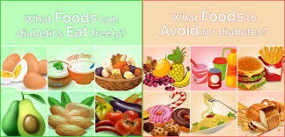

**8.** **Constipation**

Constipation is a condition in which a person has uncomfortable or infrequent bowel movements. Generally, a person is considered to be constipated when bowel movements result in passage of small amounts of hard, dry stool, usually fewer than three times a week..



**Symptoms:**

* Fewer than three stools a week.
* Hard, dry or lumpy stools.
* Straining or pain when passing stools.
* A feeling that not all stool has passed.
* A feeling that the rectum is blocked.
* The need to use a finger to pass stool.

**Exercise:**



**Benefits:**

Exercise helps constipation by lowering the time it takes food to move through the large intestine. This limits the amount of water your body absorbs from the stool. Hard, dry stools are harder to pass. Plus, aerobic exercise speeds up your breathing and heart rate.

**Foods to Include:**

1. **High-Fiber Fruits:** Apples, pears, berries, and prunes are excellent for promoting bowel regularity. Prunes, in particular, are well-known for their natural laxative effect.
2. **Vegetables:** Leafy greens (spinach, kale), broccoli, carrots, and Brussels sprouts are high in fiber and help with digestion.
3. **Whole Grains:** Brown rice, oatmeal, quinoa, and whole-wheat products are rich in fiber and aid in bowel movements.
4. **Legumes:** Beans, lentils, and chickpeas provide a good source of soluble and insoluble fiber, which helps move things along in the digestive tract.
5. **Nuts and Seeds:** Flaxseeds, chia seeds, and almonds are high in fiber and can help with regularity. Flaxseeds and chia seeds also provide healthy fats.
6. **Water-Rich Foods:** Cucumbers, melons, and citrus fruits can help keep you hydrated and aid in digestion.
7. **Probiotics:** Yogurt, kefir, and fermented foods like sauerkraut contain beneficial bacteria that support a healthy gut.

**Foods to Avoid:**

1. **Low-Fiber Foods:** Processed and refined foods like white bread, pastries, and some snacks lack fiber and can contribute to constipation.
2. **High-Fat Foods:** Fried foods, fast food, and foods high in saturated fats can slow digestion and exacerbate constipation.
3. **Dairy Products:** Some people find that dairy products, like cheese and whole milk, can contribute to constipation, especially if consumed in large amounts.
4. **Red Meat:** It’s low in fiber and can be hard to digest, which might worsen constipation.
5. **Processed Foods:** Many packaged foods are low in fiber and high in sodium, which can contribute to dehydration and constipation.
6. **Caffeinated Drinks:** Coffee and tea can lead to dehydration if consumed in excess, which can worsen constipation.

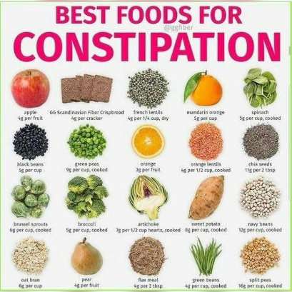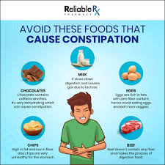

**9.** **Obesity**

Obesity is a chronic complex disease defined by excessive fat deposits that can impair health. Obesity can lead to increased risk of type 2 diabetes and heart disease, it can affect bone health and reproduction, it increases the risk of certain cancers.



**Symptoms:**

**Day-to-day problems related to obesity include:**

* breathlessness.
* increased sweating.
* snoring.
* difficulty doing physical activity.
* often feeling very tired.
* joint and back pain.
* low confidence and self-esteem.
* feeling isolated.

**Exercise:**

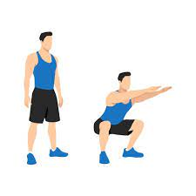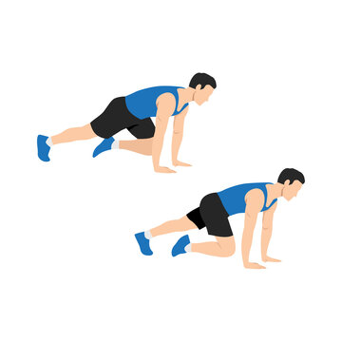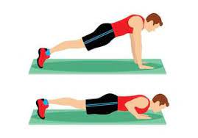

**squaets**

**Mountain climbers**

**runnung**

**pushups**

**Benefits:**

Exercise helps in increasing energy expenditure can help reduce excess adipose tissue and obesity. The current guidelines by the American College of Sports Medicine (ACSM) include aerobic or anaerobic exercise. Aerobic exercise (eg, running, cycling, rowing) is an exercise that exhausts the oxygen in the muscles.

**Foods to Include:**

1. **Vegetables:** Non-starchy vegetables like leafy greens (spinach, kale), broccoli, bell peppers, and cucumbers are low in calories and high in fiber, which helps you feel full.
2. **Fruits:** Opt for fruits high in fiber and low in calories, such as berries, apples, and oranges. They provide essential nutrients and can help curb cravings.
3. **Whole Grains:** Brown rice, quinoa, oats, and whole-wheat products provide fiber and can help with satiety and blood sugar control.
4. **Lean Proteins:** Skinless poultry, fish, tofu, and legumes (beans, lentils) are high in protein, which helps build muscle and keeps you feeling full longer.
5. **Healthy Fats:** Avocados, nuts, seeds, and olive oil offer healthy fats that can help with satiety and overall health, but should be consumed in moderation.
6. **Low-Fat Dairy or Dairy Alternatives:** Opt for low-fat or non-dairy alternatives like almond milk or Greek yogurt, which can be lower in calories while still providing important nutrients.
7. **Legumes:** Beans, lentils, and chickpeas are high in fiber and protein, which can help with satiety and weight management.

**Foods to Avoid:**

1. **Sugary Foods:** Sweets, sugary drinks, and high-calorie desserts can lead to weight gain and offer little nutritional benefit.
2. **Refined Carbohydrates:** White bread, pastries, and many processed foods can cause spikes in blood sugar levels and contribute to weight gain.
3. **Fried Foods:** Foods high in unhealthy fats, such as fried chicken and French fries, are calorie-dense and can contribute to weight gain.
4. **High-Calorie Snacks:** Chips, candy bars, and other high-calorie, low-nutrient snacks can add unnecessary calories and contribute to weight gain.
5. **Sugary Beverages:** Soda, energy drinks, and even some fruit juices can be high in calories and sugar, contributing to weight gain.
6. **High-Fat Meats:** Processed meats like bacon, sausages, and fatty cuts of red meat can be high in unhealthy fats and calories.

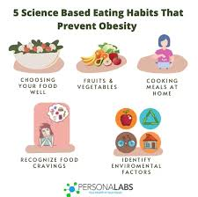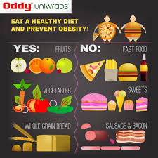

**9.** **Headache**

A headache is pain or discomfort in the head or face area. Types of headaches include migraine, tension, and cluster. Headaches can be primary or secondary. If it is secondary, it is caused by another condition. Avoiding headache triggers is the best prevention. 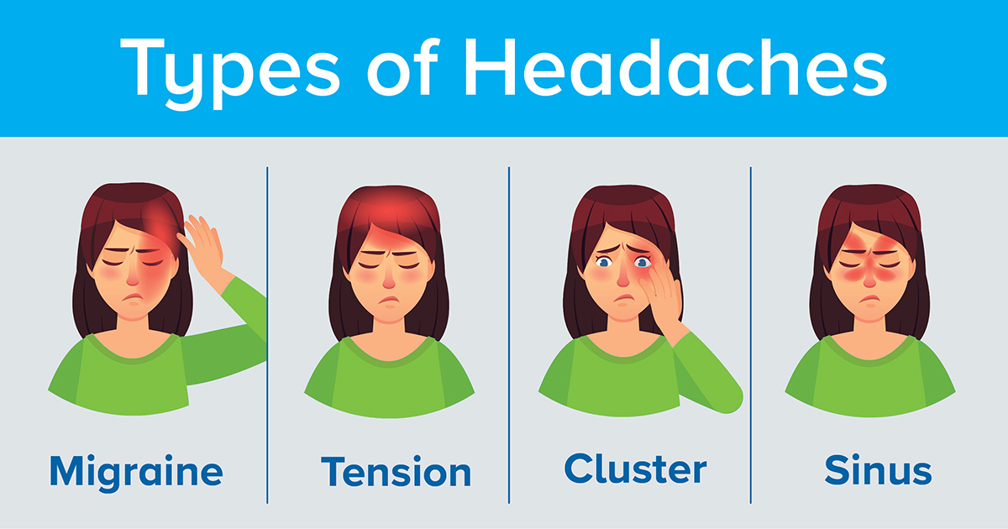

**Symptoms:**

* Pain usually on one side of your head, but often on both sides.
* Pain that throbs or pulses.
* Sensitivity to light, sound, and sometimes smell and touch.
* Nausea and vomiting.

**Exercise:**

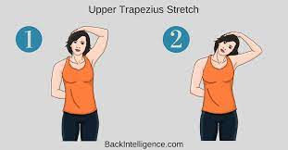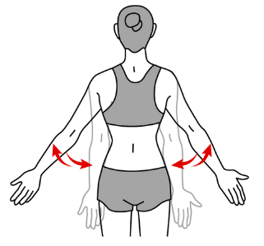

Scapular Retraction

**Cat cow stretch**

**Chin tucks**

**Upper trapezious stretch**

**Benefits:**

Healthcare professionals think stretches for headaches work by relieving tension in the upper body and reducing stress. A variety of stretches can help relieve tension in the neck, shoulders, and back. However, if headaches persist or a person experiences migraine, they should contact a doctor.

**Foods to Include:**

1. **Hydrating Foods:** Water-rich foods like cucumbers, celery, and melons can help maintain hydration, which is important for headache prevention.
2. **Leafy Greens:** Spinach, kale, and other greens are high in magnesium, which can help prevent and relieve headaches.
3. **Fatty Fish:** Salmon, mackerel, and sardines provide omega-3 fatty acids that have anti-inflammatory properties and can help reduce the frequency and severity of headaches.
4. **Nuts and Seeds:** Almonds, chia seeds, and flaxseeds are good sources of magnesium and can help prevent headaches.
5. **Whole Grains:** Oats, quinoa, and brown rice provide steady energy and can help avoid blood sugar fluctuations that might trigger headaches.
6. **Fruits:** Berries, bananas, and apples provide essential vitamins and minerals and can help maintain blood sugar levels.
7. **Herbal Teas:** Ginger, peppermint, and chamomile teas can have soothing effects and help reduce headache symptoms.

**Foods to Avoid:**

1. **Processed Meats:** Foods like bacon, sausages, and deli meats contain nitrates and can be headache triggers for some people.
2. **Aged Cheeses:** Cheeses like cheddar and blue cheese can contain tyramine, which might trigger headaches.
3. **Alcohol:** Red wine and other alcoholic beverages can dehydrate you and are common headache triggers.
4. **Caffeinated Beverages:** While caffeine can sometimes help with headaches, excessive consumption or withdrawal from caffeine can lead to headaches.
5. **Sugary Foods:** High sugar intake can cause blood sugar spikes and crashes, which may trigger headaches.
6. **Foods with Artificial Additives:** Preservatives, artificial sweeteners (like aspartame), and other additives can sometimes be headache triggers.
7. **High-Sodium Foods:** Processed and fast foods high in sodium can lead to dehydration and might exacerbate headache symptoms.

